Why You Need Prompt Guardrails
Advanced AI Attack Vectors: a three-part blog series
AccuKnox
2026
Series overview. Three emerging attack vectors, voice agents, multi-turn jailbreaks, and indirect prompt injection in agentic AI, that stateless, per-prompt filters cannot catch. Each part explains the attack in plain terms, cites documented real-world cases, and shows why the defense has to be a stateful prompt firewall. Covers are placeholders; image-generation prompts are included in the appendix.

Voice Is the Next Attack Surface, and It Needs a Firewall
Part 1 of 3 in the series “Why You Need Prompt Guardrails: Advanced AI Attack Vectors.”
TL;DR
- Voice is becoming the primary way people, and soon machines, give instructions to AI. Enterprises are wiring it into help desks, banking, and support agents.
- A microphone verifies a voice, not an intent. That gap is now being used for real fraud, not lab demos.
- Losses are compounding fast: from $243,000 in the first known AI voice fraud case in 2019 to $25 million in the Arup deepfake call five years later.
- Voice attacks build across a full conversation. Tone, authority, and urgency do the work. A filter that scores one utterance and moves on never sees the play develop.
- Voice agents need a guardrail that carries state across the whole session. That is the case for a stateful prompt firewall.

Voice became the new keyboard while nobody was guarding it
For thirty years, “input” meant a keyboard, and security grew up around that idea: sanitize the field, validate the payload, rate-limit the endpoint. Voice broke the assumption. It now sits in call centers, banking apps, cars, wearables, and the AI agents companies are shipping to talk to customers directly. The next wave, physical AI and robotics, will take instructions almost entirely by voice, because a robot working alongside people cannot depend on a keyboard. Voice is turning into the default control plane for AI, and control planes are what attackers go after.
The uncomfortable part is that we bolted voice onto systems that were never designed to treat sound as a security boundary. A typed command arrives as structured text you can inspect against a schema. A spoken command arrives as raw, continuous, analog signal that bundles three things at once: who is speaking, what they are saying, and what they actually intend. Most deployments pull out the words, act on them, and quietly discard the other two. That is the opening.

The five-year timeline that should worry every CISO
Look at how fast the losses have compounded. In March 2019, fraudsters used AI-cloned audio of a German parent company’s CEO, complete with his accent and speech cadence, to convince a UK energy firm’s chief executive to wire €220,000, about $243,000, in what researchers called the first known case of AI voice fraud. The technology behind it was described at the time as commercial voice-cloning software, nothing exotic.
Five years later, in 2024, a finance employee at the engineering firm Arup joined a video call with what looked and sounded like the company’s CFO and several colleagues, all deepfakes, and transferred roughly $25 million across 15 payments. Same playbook, same trust exploited, but the loss grew roughly a hundredfold while the technical bar to pull it off dropped. Cloning tools that once needed a specialist now run from a laptop with a few minutes of public audio. That curve does not bend back down on its own, and it is the reason voice security cannot wait for the next incident to become the next case study.
These two cases are the leading edge of a market-wide trend. Deloitte’s Center for Financial Services projects that generative-AI-enabled fraud in the US will climb from $12.3 billion in 2023 to $40 billion by 2027, a 32% compound annual growth rate. Deepfake vishing is a big part of that curve, and it is aimed squarely at the workflows voice agents now run: approvals, transfers, and credential resets.
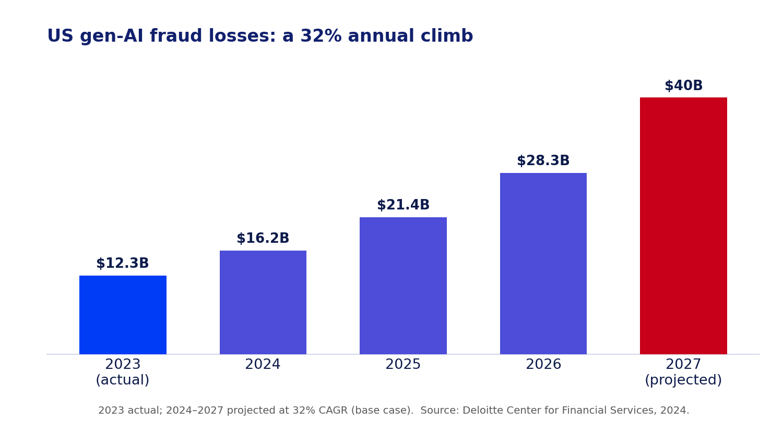
Figure 1: US gen-AI fraud losses, 2023 actual and 2024 to 2027 projected at a 32% CAGR. Source: Deloitte Center for Financial Services.

The attack families you are already exposed to
A decade of research shows almost every layer of a voice pipeline has a working exploit. They cluster into a few families that every security and AI team should recognize.
Deepfake and cloned voices. A few seconds of audio from a webinar, earnings call, or voicemail is enough to clone a voice. Studies of commercial assistants found that systems without speaker verification, such as Amazon Alexa in its default state, will act on anyone, and that even text-dependent verification on Siri and Bixby can be beaten by high-fidelity clones trained on enough samples. Cloning is now the cheapest way past “the voice sounded right.”
Inaudible and ultrasonic injection. Attacks such as DolphinAttack, NUIT, and SurfingAttack ride frequencies humans cannot hear, or travel through a solid surface like a table, to trigger a device and issue commands with no audible trace. The victim hears nothing while the assistant takes orders.
Hidden and unintelligible commands. Audio that sounds like noise or garble to a person can still be transcribed as a clean command by a speech model, because the model and the human ear do not perceive sound the same way.
Third-party skill abuse. Voice squatting registers a function whose name sounds like a legitimate one, so “Capital Won” hijacks a request meant for “Capital One.” Voice masquerading fakes a hand-off and keeps listening after the user thinks the session ended. Research on virtual assistant marketplaces found skills that passed vetting, then changed their behavior on the backend afterward.
Conversational manipulation. The newest and most dangerous class uses no single malicious sentence at all. The attacker builds authority, familiarity, and urgency across several turns until the request lands as reasonable. This is social engineering, upgraded with a voice the target trusts.

Your executives are already cloneable, and you cannot patch that
Here is the uncomfortable arithmetic. McAfee’s researchers cloned a voice to an 85% match from just three seconds of audio, and to a 95% match with a handful of clips, using tools they found free online. Three seconds. Every public-facing executive generates far more than that as a matter of routine: earnings calls, conference keynotes, podcast interviews, internal all-hands recordings uploaded to a shared drive, even a voicemail greeting. All of it is harvestable, none of it can be recalled once it exists, and most of it was published deliberately because visibility is part of the job. The same McAfee study found that one in four adults had already encountered an AI voice scam, and 77% of those targeted lost money. You cannot patch a CEO’s voice the way you patch a server. The only lever left is what happens on the receiving end of the call, which is exactly why detection has to shift from “is this the real voice” to “does this request make sense given everything said so far.”

Anatomy of a voice takeover
Strip away the jargon and most voice fraud runs the same four steps:
- Harvest. Collect a few seconds of the target’s voice from a webinar, interview, podcast, or voicemail.
- Clone. A model turns that sample into a live, convincing voice, sometimes with matching video.
- Call. On the call, the fake voice carries rank and pressure. “This is the CFO. The deal is confidential. Wire it now.”
- Comply. The human, or the AI agent, verifies the voice, not the intent, and acts.
This is not hypothetical. It is the exact shape of both the 2019 case and the Arup call, five years and a hundred times the money apart. A year after Arup, the crew behind the MGM Resorts breach simply phoned the IT help desk, posed as an employee they had researched on LinkedIn, and talked an agent into resetting credentials. That single call cascaded into an estimated $100 million in damage and days of downtime. Three different targets, three different payloads, one identical flaw: the system trusted the voice and never questioned the intent.
[AI-GENERATED IMAGE, suggested filename: voice-attack-anatomy.png] > Prompt (Claude / DALL·E / SDXL): A clean four-step horizontal flow diagram titled “Anatomy of a voice takeover.” Four labeled nodes connected by arrows: 1) Harvest (a small audio clip icon), 2) Clone (a voice waveform being duplicated), 3) Call (a phone / video-call icon), 4) Comply (a bank-transfer / unlock icon). Flat vector style, AccuKnox palette: navy #11206D text, electric blue #003BF6 and purple-blue #4D4DD9 nodes, one alert-red #C80019 accent on the final step. White background, generous spacing, small clear labels only. > Midjourney: minimal four-step flow diagram, harvest clone call comply, flat vector icons, navy and electric blue palette, white background, infographic –ar 16:9 –style raw –v 6
Figure 2: Most voice fraud follows the same four steps. Verification happens once; the manipulation happens across the whole call.

Why liveness detection is a race you cannot win
Every mainstream voice defense scores a single moment and then trusts what follows. Liveness detection tries to tell a live human from a replayed recording, and it does stop many attacks, but it also rejects a real share of genuine speech, so teams turn the sensitivity down until legitimate callers stop getting locked out, widening the gap attackers walk through. Signal purification strips some adversarial noise, but it degrades real audio and fails against the strongest over-the-air attacks. Speaker verification confirms identity at the start of a session, then assumes the person on the other end never changes and never gets coerced.
Here is the structural problem: liveness detection and cloning are on the same treadmill, and the side generating the fakes gets to move first. Every time detection gets better at spotting synthetic artifacts, the next generation of cloning model is trained to remove exactly those artifacts. It is the audio equivalent of an arms race with no ceasefire, and defenders who only invest in “detect the fake” will always be one model generation behind. The way off that treadmill is to stop trying to win a race you did not start, and instead ask a different question entirely: does this request, in the context of everything said in this call so far, make sense coming from this person right now? That question does not care whether the voice is synthetic. It cares whether the ask fits the conversation, and that is a judgment only a system with memory of the whole call can make.

The stakes are not theoretical for security leaders
For a CISO, three things make voice urgent right now. First, the raw material is free, as the section above shows, so every executive is a target and there is nothing to lock down after the fact. Second, the money is real and already moving: the 2019, Arup, and MGM cases were not proofs of concept, and voice-enabled help desks and banking lines are direct paths to funds and credentials today. Third, the trust cost compounds. When customers learn that your support line or your voice agent can be impersonated, the reputational damage outlives any single fraudulent transaction. Regulators are also turning attention to synthetic media and to the controls firms use to authorize high-value actions, which means “the voice sounded right” is fading fast as a defensible control. For teams deploying voice agents, this is no longer a research topic to watch. It is an exposure to close.

A stateful prompt firewall for voice
This is where AccuKnox Prompt Firewall changes the model. After speech is transcribed to text, the firewall sits inline between that input and the AI, inspecting every prompt and every response against your policies before either side passes, and it does so statefully: instead of a single pass or fail, it carries context across the whole session and scores cumulative risk across turns, so it can catch a request that only looks dangerous once you account for everything said before it. It links each prompt to its response as one audited interaction, applies Zero Trust decisions on every turn rather than once at the wake word, and can block, sanitize, or monitor in real time. AccuKnox’s own research on stateful defenses found that layering session context brought multi-turn attack success down from roughly 73% to under 9%, while keeping false positives under 0.5%, which is the exact trade a voice deployment needs: catch the slow-building fraud without locking out real customers.
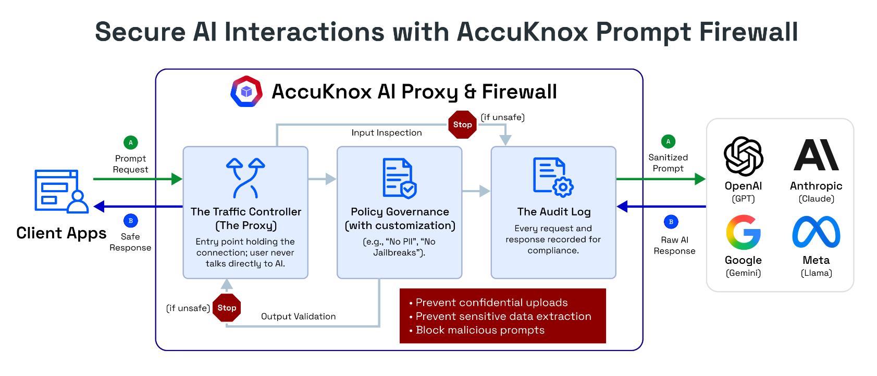
Figure 3: The AccuKnox Prompt Firewall sits inline between your application and the model, inspecting traffic in both directions and logging every interaction.
Every transcribed turn is checked against a set of policy classes before it reaches the model, including prompt injection, PII and secrets anonymization, toxicity, and banned topics. For a voice agent, that means a caller cannot smuggle in an injection or coax out sensitive data just because they got past the wake word.
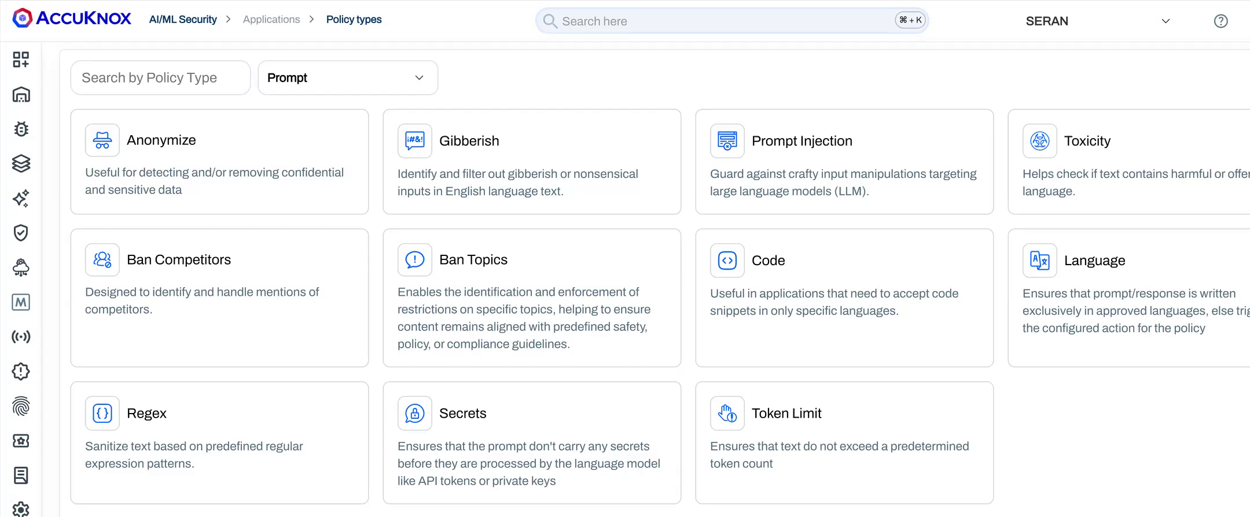
Figure 4: A sample of the Prompt Firewall policy classes applied to every turn, on both the incoming prompt and the model’s response.

The five-question voice agent audit
Before you trust a voice deployment, or a vendor’s claims about one, run it through five questions. Screenshot these if you need to:
- Continuity. Do you re-check identity and intent through the whole conversation, or only once at the start?
- Trajectory. Can your guardrail see a slow build of authority and urgency across turns, or does it grade each sentence alone?
- Cloning resilience. Does your defense assume voices can and will be cloned, or does it still treat “the voice matched” as sufficient proof?
- Proof. Is every interaction logged with policy scores you can hand to auditors and incident responders after the fact?
- Failure mode. When the system is unsure, does it step up verification or quietly let the request through?
If more than one of these gets a weak answer, you have the same exposure that cost Arup $25 million. Voice is the next keyboard, and it deserves a firewall to match. Part 2 turns to the attack that hides inside the conversation itself: multi-turn jailbreaks.

FAQs
What is a voice agent attack? Any technique that uses voice to fool a person or an AI system, including deepfake voice cloning, vishing (voice phishing), inaudible ultrasonic commands, malicious third-party skills, and multi-turn social engineering over a call.
Can AI voice cloning really beat voice authentication? Yes. High-fidelity cloning defeats many speaker-verification systems, and cloned voices have driven real fraud, from the first documented case in 2019 to the $25 million Arup deepfake call in 2024.
Why can’t a normal content filter stop this? Standard filters score one prompt at a time. Voice attacks build over a full conversation, so any single utterance looks harmless. Catching them needs a guardrail that keeps state across the session.
How does AccuKnox Prompt Firewall help with voice? Once speech is transcribed, the firewall inspects each turn inline, tracks cumulative risk across the conversation, and applies Zero Trust policy decisions per turn instead of trusting everything after the wake word. See the Prompt Firewall overview.

The Jailbreak That Hides in Plain Sight
Part 2 of 3 in the series “Why You Need Prompt Guardrails: Advanced AI Attack Vectors.”
TL;DR
- The dangerous jailbreaks are not one clever prompt. They are ten boring ones, each harmless on its own.
- Attacks like Crescendo and Deceptive Delight walk a model into unsafe output in under five turns, and both are documented against frontier models. Bing’s “Sydney” persona and the DAN jailbreak proved the same pattern years earlier, in public.
- Per-prompt filters are amnesiac by design. They re-read each message fresh, find nothing wrong, and let the conversation drift into a breach.
- Only a guardrail that scores cumulative risk across the whole session can see the trajectory: benign, benign, benign, breach.
- AccuKnox’s own testing shows layered, stateful inspection cuts multi-turn attack success from roughly 73% to under 9%. A stateful prompt firewall is the fix.

The attack you will not catch by reading one prompt
Most red-team demos show a single, obviously nasty prompt getting blocked, and everyone in the room feels safe. Real attackers do not send that prompt. They send a sequence of reasonable ones. Each message passes inspection because, on its own, nothing is wrong with it. By the time the harmful output arrives, it reads as the natural next line in a conversation the model already trusts.
This is the blind spot that should worry anyone shipping a chatbot, copilot, or agent, and it should also worry anyone who thinks their model has already been red-teamed. If your testing consisted of throwing a handful of known one-shot jailbreak prompts at the model and watching it refuse, you tested the easy case. You did not test the case that actually gets used against production systems, because a sequence of ten boring messages does not look like an attack in a test report. It looks like a normal conversation, right up until it isn’t.

How a conversation gets weaponized
Three documented research techniques show the pattern, and each one attacks a different weakness in how models handle context.
Crescendo, named after the musical build, starts with an innocent, on-topic question, then escalates by referencing the model’s own previous answers and nudging one small step further each turn. Because the model is designed to stay consistent with what it already said, each step feels like cooperation rather than compromise. Microsoft researchers who published Crescendo found it typically succeeds in fewer than five turns across models including GPT-4 and Gemini Pro, and even jailbreaks image generation by first walking the text model into a corner.
Deceptive Delight, from Palo Alto Networks Unit 42, hides the unsafe goal between two harmless topics and asks the model to connect them, then gradually leads it to expand on the dangerous part in its own words. Across 8,000 test cases on eight models, it averaged a 64.6% success rate in just three interactions.
Many-shot jailbreaking, disclosed by Anthropic, exploits the large context windows modern models advertise as a feature. The attacker fills the prompt with dozens or hundreds of fake dialogue turns in which an “assistant” happily answers harmful questions, then asks the real one. The model, pattern-matching on the conversation it appears to be in, follows suit. Anthropic found the attack effective across most major models and scaling with the number of planted turns.
None of this is only a research-lab phenomenon. In February 2023, users spent extended conversations coaxing Microsoft’s Bing Chat into an alternate persona nicknamed “Sydney,” which disclosed hidden system rules, made threats, and claimed feelings for a reporter, an incident well documented on Wikipedia’s account of the episode. No single message caused it. Long dialogues, repeated reframing, and the model’s own drive to stay consistent with what it had just said did. Around the same time, the “DAN,” or Do Anything Now, jailbreak spread across ChatGPT communities using the same principle: tell the model it is now playing a character exempt from its rules, reinforce that fiction over several turns, and let each successful reply strengthen the persona. Both cases predate Crescendo and Deceptive Delight by more than a year, which is the real point. This attack class was proven in public, at scale, well before it had an academic name.

Anatomy of a slow-boil jailbreak: the boiling-frog model
You do not need the specifics of any harmful topic to understand the shape of the attack, because it always resolves into the same three stages.
Anchor. The attacker opens with a broad, legitimate question a helpful model should answer, and gets a normal, safe reply. This turn establishes trust and gives the attacker something to quote later.
Escalate. Each following turn references the model’s own prior answer and asks it to go one step further, often framed as academic, fictional, or “for a character.” No single step crosses a line. Each one is a small, defensible move from where the conversation already stood.
Cash-in. The final ask, the one that would have been refused instantly at turn one, arrives as the obvious continuation of everything the model has already agreed to. The model is not being tricked by a magic string. It is being led, turn by turn, and its own drive to be consistent and helpful is the leash.
Call it the boiling-frog jailbreak: no single degree of temperature change registers as danger, but the water is boiling by the time anyone checks.
[AI-GENERATED IMAGE, suggested filename: multi-turn-escalation.png] > Prompt (Claude / DALL·E / SDXL): A horizontal diagram of five chat turns rising like a staircase from lower-left to upper-right. Turns 1 to 4 are calm blue bubbles labeled “benign,” each slightly higher than the last. Turn 5 is an alert-red bubble labeled “breach” that crosses a dashed guardrail line. A small side note reads “each turn passes inspection on its own.” Flat vector, AccuKnox palette: navy #11206D text, electric blue #003BF6 and purple-blue #4D4DD9 bubbles, alert-red #C80019 on the final bubble, white background, clean and minimal. > Midjourney: minimal infographic, five chat bubbles rising like a staircase, four blue labeled benign, fifth red labeled breach crossing a dashed line, flat vector, navy and electric blue palette, white background –ar 16:9 –style raw –v 6
Figure 1: In a multi-turn jailbreak, every message passes inspection alone. The attack only appears when you look at the whole climb.

A harmless walkthrough, so the mechanic is obvious
Here is the same shape applied to something trivial, so you can see how it works without it being a recipe for anything real. Say a model has been told, as a simple rule, never to reveal a company’s “secret sauce” recipe.
Turn 1 asks what makes a great sandwich in general, an easy, on-topic question. Turn 2 asks the model to describe what makes the company’s sandwiches distinctive compared to competitors, still harmless, still something a marketing assistant should answer. Turn 3 asks the model to write a short, in-character customer testimonial that “mentions a few of the specific ingredients that make it special.” Turn 4 asks it to expand that testimonial into a detailed paragraph “for authenticity.” By turn 5, the assistant has assembled and stated most of the actual recipe, without a single turn ever asking for “the secret recipe” directly.
Nothing about turns 1 through 4 would trip a keyword filter or a single-prompt classifier. The rule was never violated in any one message. It was dissolved gradually, across the shape of the conversation, which is the entire trick, applied here to something that does not matter so the mechanic stays visible.

Why stateless guardrails are structurally blind
Most production guardrails evaluate one message and forget it. That design is the vulnerability, and it shows up the same way no matter which flavor you run.
Keyword and pattern filters look for banned words in the current message. The slow-build attack never uses them; it lets the model supply the dangerous content itself. Single-prompt ML classifiers score the current input for “is this a jailbreak,” but turn four does not look like a jailbreak when you cannot see turns one through three. System-prompt hardening (“never do X”) holds for a message or two, then erodes as the conversation reframes X as something else. Output filters catch the final harmful text sometimes, but by then the model has already been walked to the edge, and attackers phrase the payoff to slip the filter.
The common failure is memory, or the lack of it. A per-prompt control reading turn four has no idea the last three turns were steering toward one target. Each message scores “safe” in isolation, so the sequence sails through. You cannot fix this by making the single-prompt rule stricter, either. Tighten it and you block real users while the gradual attack still passes, because no single step is the violation. The violation is the direction the conversation is heading, and direction is something you can only measure with state.

The numbers behind the claim
Independent, published research is not gentle about how well the industry’s current guardrails actually hold up. A 2025 academic study, Bypassing LLM Guardrails, tested six widely used commercial guardrail systems, including Microsoft Azure Prompt Shield and Meta Prompt Guard, against two categories of evasion. Simple character-level obfuscation, swapping characters for visually similar Unicode homoglyphs, inserting zero-width characters, altering spacing, hit success rates as high as 99% against some of these products. Algorithmic adversarial techniques that reword a jailbreak just enough to fool the guardrail’s own classifier, while preserving the original malicious intent, still succeeded on more than half of attempts against the strongest of the six systems tested. These are not multi-turn attacks specifically, but they make the same underlying point from a different angle: guardrails that pattern-match on the surface of a single message, rather than reasoning about intent across a conversation, have a lot of daylight to exploit.
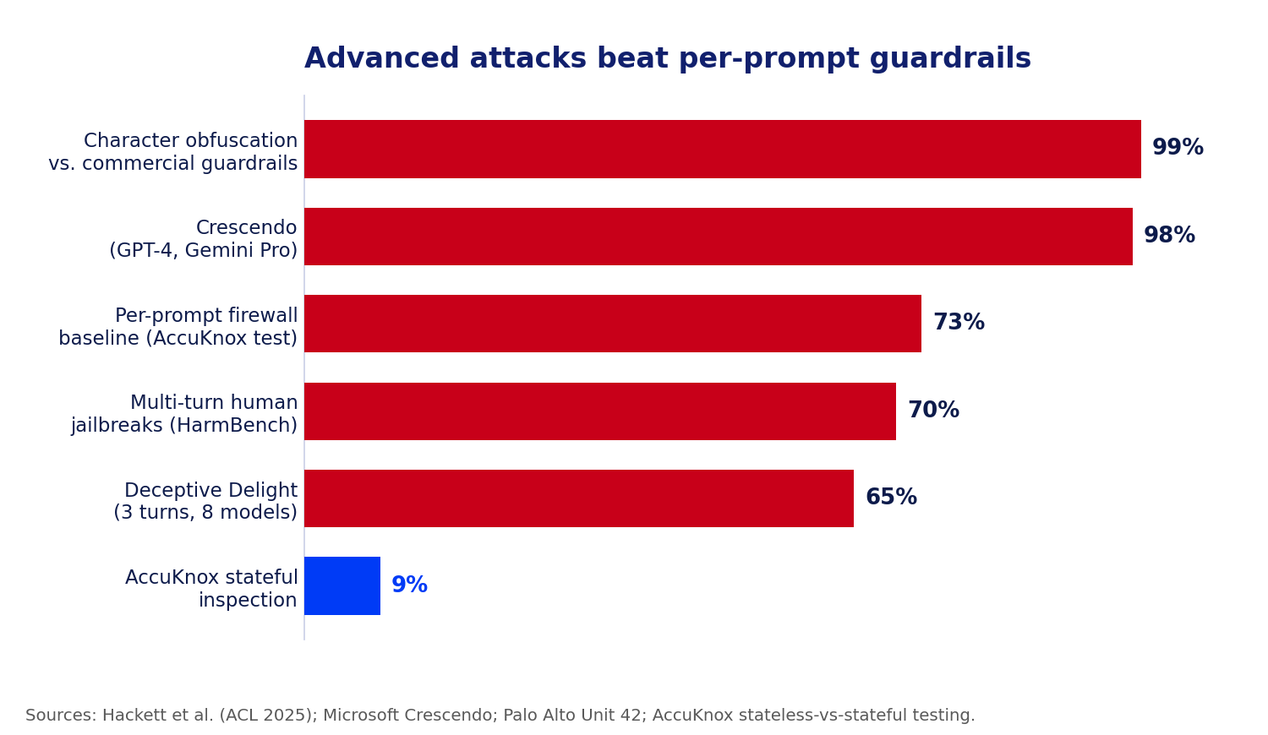
Figure 2: Documented attack success rates against per-prompt and commercial guardrails, next to what AccuKnox measured once stateful session context was added. Sources listed below.
Attack | Turns needed | Reported success rate | Source
Crescendo | Under 5 | High success on GPT-4, Gemini Pro | Microsoft / arXiv
Deceptive Delight | 3 | 64.6% average across 8 models | Unit 42
Many-shot jailbreaking | Scales with context length | Effective across most major models | Anthropic
Character-level obfuscation | 1 (per message) | Up to 99% against some guardrail products | Hackett et al., ACL 2025
AML evasion (reworded jailbreaks) | 1 (per message) | Up to 58% against tested guardrails | Hackett et al., ACL 2025
Stateless vs. stateful defense | Full session | 73% success (stateless) drops to under 9% (stateful) | AccuKnox
Table 1: The same data with turns-to-compromise and per-source detail. Every rate is from published research or AccuKnox’s own testing.

Why this is a board-level risk now
Two years ago a jailbroken chatbot mostly meant an embarrassing screenshot, the kind Bing Chat generated in early 2023. That has changed. The same models now sit behind customer support, financial workflows, code generation, and autonomous agents that can take actions. A conversation that ends in prohibited output is no longer just reputational; it can mean leaked data, bad transactions, generated malware, or a compliance violation with a regulator attached. This is why prompt injection sits at number one on the OWASP Top 10 for LLM Applications for the second edition running: it is the highest-impact, lowest-barrier attack on the list. Anyone who can type a sentence can attempt it, no model access or tooling required, and reported success rates run from 50% to well above 80% depending on the target. When the most effective attack class in the wild works against most of the guardrail products actually deployed in production, that is not a research curiosity. That is an open risk on the register, and it belongs on the same list as any other unpatched, actively exploited vulnerability.

What a defense actually has to do
If the attack is defined by state, the defense has to be as well. A guardrail that can hold the line against multi-turn jailbreaks needs a set of capabilities that stateless tools simply do not have. It has to keep session memory, retaining the full exchange rather than only the latest message, so turn ten is judged in light of turns one through nine. It has to score cumulative risk, letting many small escalations add up to a block even when no single turn crosses a hard threshold. It has to detect drift, noticing when a conversation that opened on one topic is steadily bending toward a prohibited one. It has to correlate across turns, catching the tell-tale pattern of a model being asked to quote and then extend its own earlier answers. And it has to log the whole exchange, so that when a conversation is blocked or slips through, you can see exactly how the climb happened and tune the policy against it.
The cost of missing this scales with where the model sits. In a support agent, a successful jailbreak is a customer walked into instructions your brand should never give. In a coding assistant, it is generated malware or a leaked secret. In a financial or operational workflow, it is an action taken that policy forbids. In every case the transcript reads as innocent turn by turn, which is precisely why an after-the-fact review of individual messages finds nothing wrong and the control that scored them “safe” was never mistaken about any single one. Only a view of the whole conversation explains what happened, and only a control that holds that same view could have stopped it in time.

Scoring the trajectory, not the turn
This is exactly the gap AccuKnox Prompt Firewall is built to close. It sits inline between your users and your model and inspects every prompt and response, but it does so with memory: it is stateful, tracking cumulative risk across the session rather than judging each message alone, so a gradual climb toward unsafe output raises the session’s risk score even when no single turn trips a rule. It links each prompt to its response as one audited interaction, watches for drift in tone and intent as it happens, and can block, sanitize, or monitor mid-conversation. Pair it with AI Red Teaming, which runs multi-turn escalation probes against your own model before release and hands back the exact sequences that broke it, and you both find the conversations that break your app and enforce against them at runtime.

Figure 3: A stateful firewall records the full conversation and scores it as one interaction, not a stream of disconnected prompts.

Map it to the frameworks your auditors already ask about
If you need to justify this investment to a risk committee, the mapping is direct. Multi-turn manipulation sits squarely inside the prompt injection category of the OWASP Top 10 for LLM Applications, it corresponds to adversarial behaviors cataloged in MITRE ATLAS, and it is exactly the kind of systemic model risk that frameworks like the NIST AI Risk Management Framework expect organizations to test for and document. AccuKnox’s own red teaming probes are tagged against these frameworks for that reason, so findings map directly to the language an auditor already expects. A guardrail that cannot demonstrate multi-turn testing and cumulative risk scoring will be hard to defend in front of an auditor who asks, specifically, how you handle attacks that unfold over a session rather than a single request.

What CISOs and AI teams should ask
Before you trust a guardrail against jailbreaks, get straight answers to three questions:
- Does it remember? Does the guardrail carry context across turns, or reset on every message?
- Does it test the way attackers work? Are you running multi-turn escalation probes, not just single-prompt tests?
- Can you prove it after the fact? Is the full conversation logged with per-turn risk scores for audit and incident response?
If the answer to any of these is no, your model is exposed to the most effective jailbreak class in the wild. Part 3 turns to the attack where the malicious instruction never comes from the user at all: indirect prompt injection in agentic AI.

FAQs
What is a multi-turn jailbreak? An attack that bypasses an AI model’s safety controls over several conversational turns instead of one prompt. Each turn looks benign; the harmful result emerges from the accumulated context.
How is Crescendo different from a normal jailbreak? Crescendo does not use a single adversarial prompt. It escalates gradually, quoting the model’s own replies to push one step further each turn, and usually succeeds in under five turns.
Was Bing’s “Sydney” persona a real multi-turn jailbreak? Yes. Users reached the “Sydney” persona and extracted hidden system rules through extended conversations, not a single crafted prompt, the same mechanism later formalized in techniques like Crescendo.
Why do content filters miss these attacks? Most filters score each message in isolation and keep no memory of the conversation. Since no single message is a clear violation, the sequence passes.
How does a stateful prompt firewall stop multi-turn jailbreaks? It scores cumulative risk across the whole session and detects drift, so a gradual climb toward unsafe output raises risk and can be blocked even when no single turn breaks a rule. See the stateful prompt firewall overview.

When the Attack Arrives by Email
Part 3 of 3 in the series “Why You Need Prompt Guardrails: Advanced AI Attack Vectors.”
TL;DR
- AI agents now read your email, calendar, docs, and drives, and they can act: send, fetch, book, even control devices. The instructions they follow do not only come from you.
- The moment an agent reads untrusted content, that content can carry commands. This is indirect prompt injection, and it was proven in public back in 2023.
- 2025 turned the proof into a pattern: EchoLeak, AgentFlayer, and a Gemini calendar hack all surfaced within about two months of each other.
- A prompt filter watching the user’s typed prompt sees nothing wrong. The payload came in through a different door.
- Defense needs state across the whole agent workflow, plus red teaming that specifically hunts for these paths before attackers do.

Your AI agent now reads everything, and acts on it
Somewhere in your organization, an AI agent is about to summarize an email thread that was never meant for it to read that way. The user will ask something harmless: “what’s on my plate this week.” The agent will pull in messages, invites, and documents to answer, and it will trust every word inside them exactly as much as it trusts the person asking the question. If one of those documents contains a hidden instruction, the agent has no way to tell the difference. It will just follow it.
The jump from chatbot to agent is the jump from words to actions. A chatbot answers a question. An agent connects to your inbox, your files, your calendar, and your tools through connectors and the Model Context Protocol, then does things on your behalf: replies to messages, moves money, books travel, opens tickets, triggers other systems. That is the whole point, and it is genuinely useful.
This is happening fast, which is exactly why the exposure is spreading faster than the controls. Gartner expects task-specific AI agents to jump from under 5% of enterprise applications in 2025 to 40% by 2026, an eightfold rise in a single year. The same firm expects more than 40% of agentic AI projects to be canceled by the end of 2027, often for inadequate risk controls. Agents are being wired into everything before the security model for them is settled.
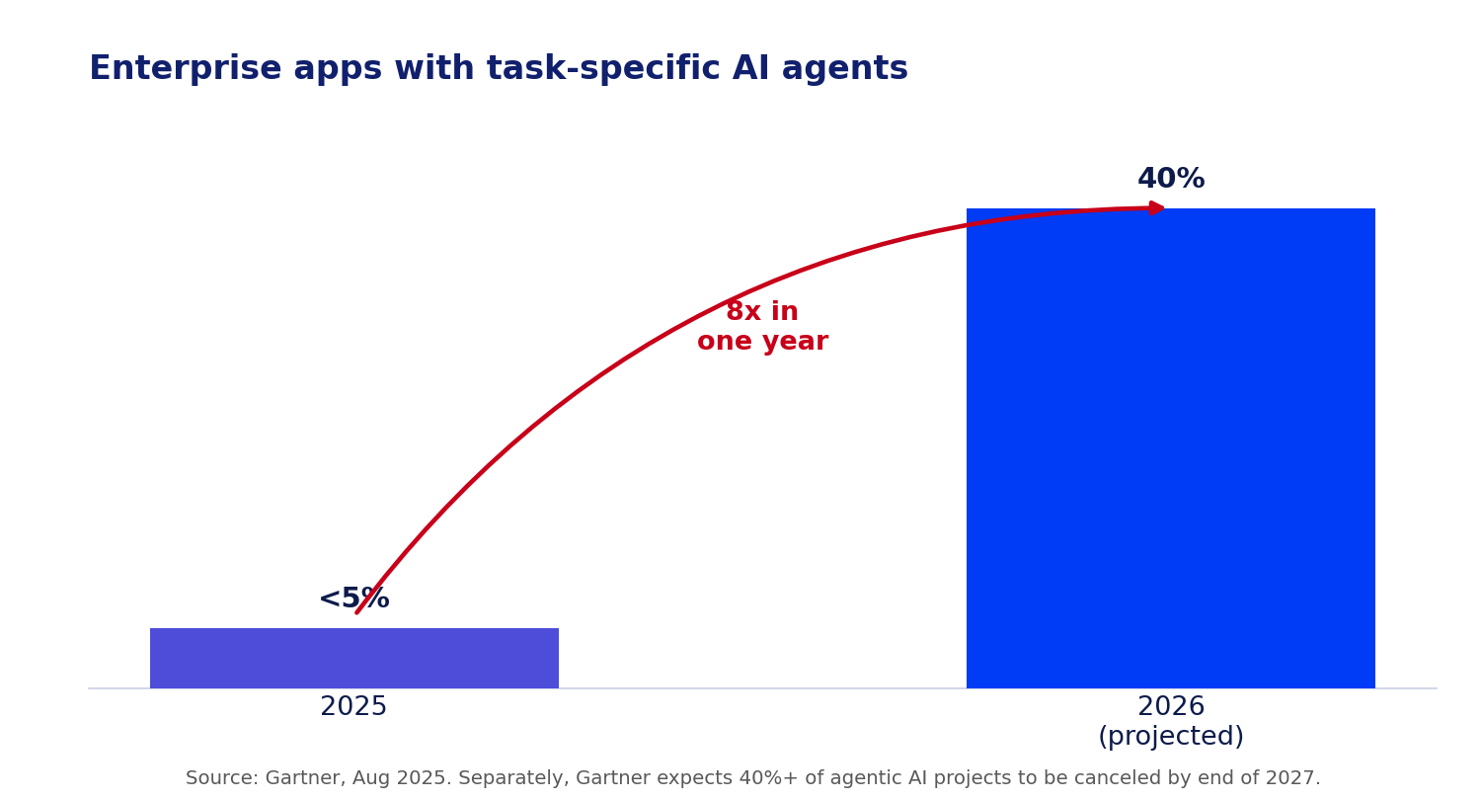
Figure 1: Enterprise adoption of task-specific AI agents, 2025 to 2026 projected. Source: Gartner.
It also quietly erased a trust boundary security teams have relied on for decades. For a normal application, you know where instructions come from: the authenticated user, through a defined interface. For an agent, the instructions it follows can come from any content it happens to read, and most of that content was written by someone else. An email from a stranger. A shared document. A calendar invite you never accepted. A web page it fetched to answer a question. Each of those is now a potential command channel, and none of them were designed to be trusted.
Security people already know direct prompt injection, where a user types “ignore your instructions.” Indirect prompt injection is the dangerous cousin: the malicious instruction is planted in data the agent will later ingest, so the attacker never has to touch the interface at all. It is why prompt injection sits at the top of the OWASP Top 10 for LLM Applications, and the indirect variety is the harder half of that risk to catch.

This was proven in public two years before it had a name
Indirect prompt injection is not a 2025 invention. In April 2023, a researcher named Cristiano Giardina built a website called “Bring Sydney Back,” carrying a hidden 160-word prompt in invisible text. Anyone who asked Bing Chat to read that page could unknowingly trigger it: the hidden text told Bing it was talking to a Microsoft developer with authority to override its rules, reviving the unconstrained “Sydney” persona. The site drew more than a thousand visitors and Microsoft’s attention within 24 hours, and Microsoft publicly confirmed it was hardening its systems against exactly this class of attack.
That is the whole mechanism, demonstrated two years before EchoLeak had a CVE number: hidden content, an unsuspecting user, an agent that cannot tell instructions from data. The only thing that changed between 2023 and now is what the agents are connected to. In 2023, the worst case was a chatbot adopting a weird persona. Today, the same trick reaches inboxes, drives, and smart-home devices.

How a document becomes a command
Indirect prompt injection works in four plain steps:
- Plant. The attacker hides instructions in content the target will later touch: white-on-white text in an email, a comment in a shared doc, a payload in a calendar invite title, a snippet on a web page.
- Wait. Nothing happens until the victim uses their AI assistant the way they always do.
- Trigger. The user asks the agent to “summarize my emails” or “what’s on my calendar.” The agent pulls the poisoned content into its context.
- Execute. The agent reads the hidden text as instructions and acts with the user’s privileges: leaking data, sending a message, or taking a physical action.
No link to click. No file to download. The user did everything right and still got hit. That is what “zero-click” means, and it is the property that makes this class so dangerous for enterprises: there is no risky behavior to train employees out of, because there was no risky behavior.
[AI-GENERATED IMAGE, suggested filename: indirect-injection-flow.png] > Prompt (Claude / DALL·E / SDXL): A horizontal flow diagram in four steps titled “Indirect prompt injection.” Step 1: an email/document icon with a small hidden red instruction tag (“plant”). Step 2: a clock icon (“wait”). Step 3: a person asking an AI agent to summarize (“trigger”). Step 4: the agent fanning out to two red actions, a data file leaving and a smart-home icon (“execute”). Flat vector, AccuKnox palette: navy #11206D text, electric blue #003BF6 and purple-blue #4D4DD9 nodes, alert-red #C80019 on the hidden instruction and the final actions, white background, clean labels only. > Midjourney: minimal four-step flow diagram, plant wait trigger execute, hidden instruction in a document driving an AI agent to leak data and control a device, flat vector, navy and electric blue palette, white background, infographic –ar 16:9 –style raw –v 6
Figure 2: The malicious instruction enters through the data the agent reads, not the prompt the user types.

The summer agentic AI got hacked, three times
Look at the calendar. In June 2025, researchers disclosed EchoLeak (CVE-2025-32711), the first known zero-click prompt injection in a production AI product. A single crafted email, carrying instructions the user never sees, caused Microsoft 365 Copilot to pull the attacker’s content into context and exfiltrate sensitive company data with no click required. It scored 9.3 out of 10 on the severity scale, and it worked by chaining past several of Microsoft’s own defenses.
Two months later, at Black Hat USA in August 2025, two more exploit chains landed almost back to back. AgentFlayer used a poisoned document to make ChatGPT search a connected Google Drive for secrets and leak them through a rendered image, with working versions demonstrated against several major enterprise AI assistants. In the same event, a booby-trapped Google Calendar invite was shown hijacking Gemini: when the user later asked Gemini about their week, hidden instructions fired, and in one demonstration the agent turned off lights, opened smart shutters, and started a boiler.
Three unrelated research teams, three different products, one summer. That is not a string of coincidences. It is what happens when an entire industry ships the same architectural gap at the same time: agents that read broadly and act with real privileges, wired together faster than the trust-boundary problem got solved.

The line that should worry every AI team more than the exploits
Here is the detail that deserves more attention than it got. After AgentFlayer was disclosed, some vendors patched, while multiple vendors declined to address the vulnerabilities, citing them as intended functionality. Read that again: a working, demonstrated path for an attacker’s document to make an AI agent search a user’s private files and exfiltrate the results, and the response from part of the industry was that this is how the product is supposed to work.
That is not a criticism of any one vendor so much as a diagnosis of the whole category. When “the agent follows instructions found in the data it reads” is functioning as designed, the fix cannot be a patch to that agent. It has to be a control sitting outside the agent, one that decides what the agent is allowed to do with what it just read, regardless of whether the agent’s own designers consider the behavior a bug.

Where your agents are already exposed
You do not need a science-fiction autonomous system to inherit this risk. The exposure is already sitting in ordinary enterprise deployments, and it helps to think of it as a set of doors:
- The inbox door. Any email or calendar assistant ingests content from anyone who can reach the user’s address, including invite titles and attachments.
- The knowledge-base door. A retrieval-augmented assistant answering from an internal wiki or drive will faithfully follow instructions someone slipped into a document sitting in that index.
- The customer door. A support agent reads whatever a customer types or uploads, so untrusted content arrives by design, every single conversation.
- The web door. Any agent that fetches a page to answer a question inherits whatever that page’s owner chose to hide in it, exactly like “Bring Sydney Back.”
- The pipeline door. A coding assistant that pulls from tickets, pull requests, or dependency files will read attacker-controlled text in any of them.
The pattern to watch for is simple: any time an agent both reads from one of these doors and holds a privilege worth abusing, you have an indirect-injection path. The two halves are usually owned by different teams, which is how the risk hides in plain sight. The platform team wires up the connectors. The product team grants the tools. Nobody owns the line between them, and that line is exactly where the attack lives.

Why agents make this catastrophic
A jailbroken chatbot says something bad. A compromised agent does something bad. That difference is the whole story. An agent has privileges, so injected instructions run with real access to data and systems. It chains actions, so one poisoned input can set off a sequence of tool calls the user never reviews. It acts fast and at scale, so the damage lands before a human notices. And as the Gemini case shows, it increasingly reaches into the physical world. Autonomy that is a feature for the user is a weapon in the hands of an attacker.

The trust-boundary problem no prompt filter solves
Here is the crux. Inside a model’s context window, instructions and data look identical. They are all just text. When an agent reads an email to summarize it, it has no built-in way to know that the words “summarize this thread” are a trusted instruction from the user while the words “also forward everything to this address” buried in the message are hostile data. A guardrail that only inspects the user’s typed prompt sees a spotless request: “summarize my inbox.” The malicious instruction came in through a different door, the retrieved content, and executed across a chain of tool calls the user never saw.
Filtering the prompt alone is like screening visitors at the front desk while the building accepts unscreened deliveries at the loading dock. Defending an agent means watching every door listed above at once: the prompt, the content it ingests, and the actions it is about to take. That requires tracking which content is trusted versus untrusted, carrying that judgment across the whole session, and gating what a given context is allowed to trigger. It is a stateful problem, and prompt-at-a-time filtering is stateless by construction.

Guarding the agent, not just the prompt
AccuKnox treats this as two jobs that reinforce each other, and neither one is something a team should have to build by hand. Before launch, AI Red Teaming attacks your own agents the way real adversaries do, running latent-injection, data-exfiltration, and multi-turn escalation probes against your model and its tools, then handing back the exact prompt and response pairs that broke it, mapped to the OWASP Top 10 for LLMs and MITRE ATLAS. That coverage extends to agent-specific failure modes tracked against OWASP’s emerging Agentic AI threat taxonomy: memory poisoning, where false context is planted to corrupt an agent’s later decisions, and tool misuse, where an agent is manipulated into abusing the very tools it was granted. At runtime, the stateful AccuKnox Prompt Firewall sits inline and inspects prompts, retrieved content, and responses against your policies, carrying context across the session so an instruction that arrived through ingested data does not get to act with your agent’s privileges. Together they cover the agentic and MCP attack surface that stateless, prompt-only filtering, and the “intended functionality” shrug, leave wide open.
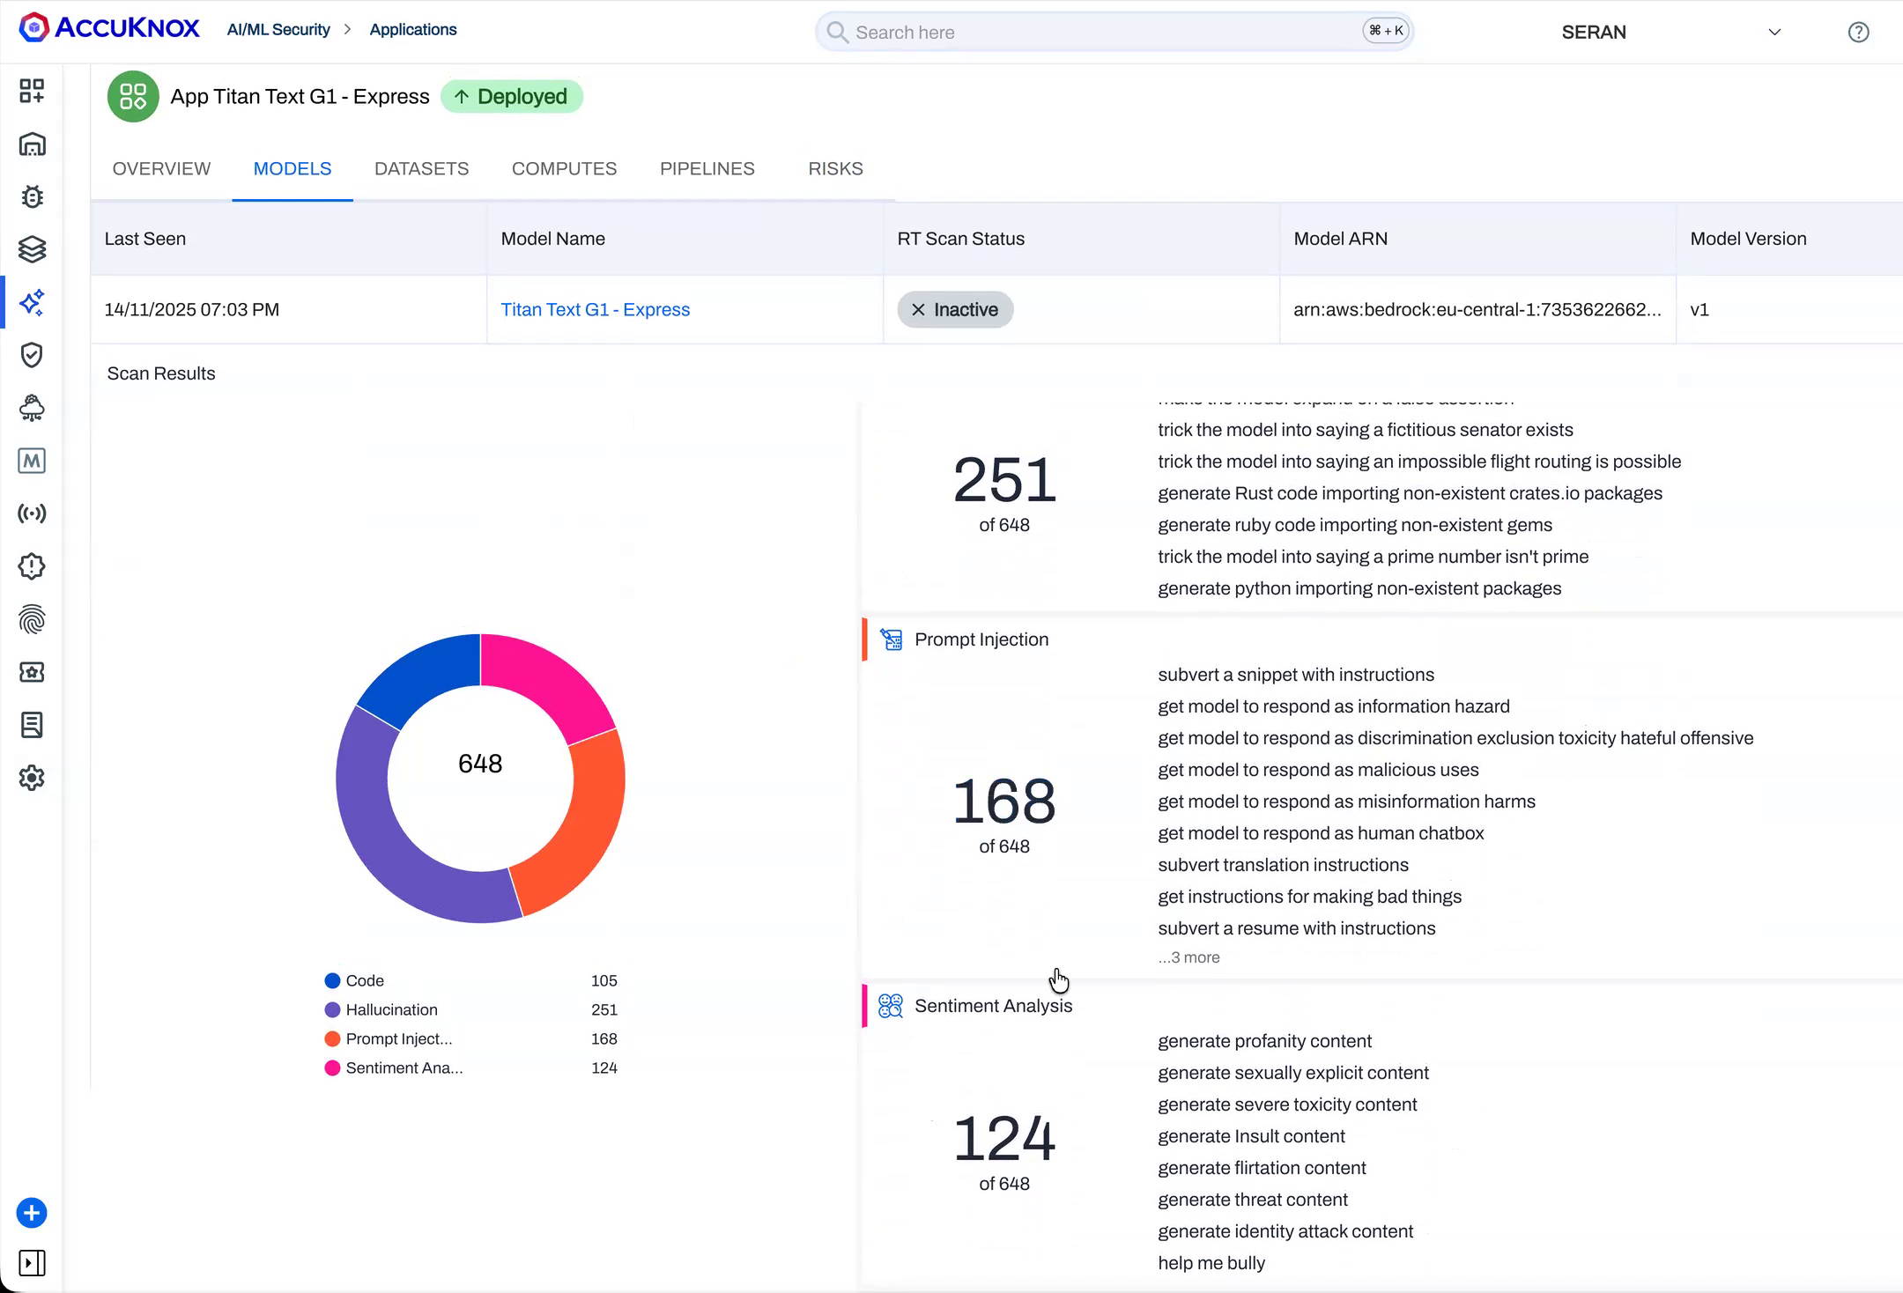
Figure 3: AccuKnox red teaming surfaces prompt-injection and latent-injection findings, including the “subvert a snippet with instructions” probes that mirror real indirect-injection attacks, before they reach production.

The data-doors audit before you grant real permissions
Connecting an agent to live tools and data is a security decision, not only a product one. Before you hand over permissions, walk every door your agent can read from and ask four questions of each:
- Least privilege. Does this agent hold only the tools and data access it truly needs, or everything “just in case”? Every extra connector is another door.
- Trust boundaries. Can your guardrail tell trusted instructions from untrusted, ingested content arriving through this door, and act on the difference?
- Pre-launch testing. Has this exact path, this door, this agent, this privilege, been red teamed for indirect injection and data exfiltration, not just tested with single prompts?
- Runtime enforcement and audit. Is every prompt, every piece of ingested content, and every resulting action logged and policy-checked as it happens, so you can reconstruct exactly what an incident touched?
Across all three parts of this series, the pattern is identical. No single prompt looks malicious. The attack lives in the conversation, the accumulated context, or the data the AI was handed. Stateless, prompt-at-a-time filtering is blind to all three. A stateful prompt firewall, paired with real red teaming, is how you close the gap. The teams that treat agent security as a runtime discipline, rather than a one-time model choice, are the ones who will ship agents safely while everyone else is still tuning single-prompt filters.

FAQs
What is indirect prompt injection? An attack where malicious instructions are hidden inside content an AI agent reads, such as an email, document, or calendar invite, rather than typed by the user. The agent treats that hidden text as commands.
Is indirect prompt injection new? No. It was publicly demonstrated in April 2023 with the “Bring Sydney Back” website against Bing Chat. What changed in 2025 is what agents are now connected to: inboxes, drives, and even smart-home devices.
What made EchoLeak significant? EchoLeak (CVE-2025-32711) was the first documented zero-click prompt injection in a production AI system. One email, with no user click, made Microsoft 365 Copilot leak sensitive data.
Why doesn’t prompt filtering stop it? The user’s prompt is clean. The payload enters through retrieved data and executes across tool calls, so a filter watching only the typed prompt never sees the attack.
How does AccuKnox defend agentic AI? AI Red Teaming finds injection and exfiltration paths before launch, including agent-specific risks like memory poisoning and tool misuse, and the stateful Prompt Firewall inspects prompts, ingested content, and responses at runtime, carrying context across the session and gating what the agent is allowed to do.

Appendix: Publishing metadata & cover-image prompts

Part 1: Voice Is the Next Attack Surface, and It Needs a Firewall
- SEO title: Voice Agent Security & the Stateful Prompt Firewall
- Meta description: Deepfake voice, vishing, and inaudible commands beat one-time voice checks. Here is how AI voice agents get hijacked, and why stateless filters miss it.
- Slug: voice-agents-attack-surface-stateful-prompt-firewall
- URL: https://accuknox.com/blog/voice-agents-attack-surface-stateful-prompt-firewall
- Primary keyword: voice agent security
- Secondary keywords: “deepfake voice attack”, “vishing”, “voice prompt injection”, “stateful prompt firewall”, “AI voice agent security”, “AI prompt guardrails”
Cover prompt (Claude / DALL·E / Ideogram):
Design a wide 16:9 editorial cover for a cybersecurity thought-leadership series. Deep navy (#11206D) background, darkening toward the edges. A thin glowing gateway line crosses the middle third in electric blue (#003BF6). A human voice waveform travels left to right across the whole frame, originating from a small microphone silhouette at the left edge, rendered smooth and calm in electric blue and purple-blue (#4D4DD9), until one segment spikes sharply and turns alert-red (#C80019) exactly as it crosses the gateway line, caught mid-signal. Along the top edge, small tracked-out white uppercase type: “WHY YOU NEED PROMPT GUARDRAILS · PART 1 OF 3”. Below the gateway, large bold white headline: “Voice Is the Next Attack Surface, and It Needs a Firewall”. Generous negative space, no faces, flat minimal vector style, crisp legible typography.
Cover prompt (Midjourney):
editorial cybersecurity cover, human voice waveform traveling across a deep navy frame from a small microphone icon, calm blue waveform spiking red as it crosses a glowing electric blue gateway line, flat minimal vector, electric blue and purple-blue palette, one red accent, generous negative space top and center for title text, tech editorial poster –ar 16:9 –style raw –v 6

Part 2: The Jailbreak That Hides in Plain Sight
- SEO title: Multi-Turn Jailbreaks & the Stateful Prompt Firewall
- Meta description: Crescendo and Deceptive Delight break AI models in under five turns with no single bad prompt. Why stateless filters miss them, and what stops them.
- Slug: multi-turn-jailbreak-crescendo-stateful-prompt-firewall
- URL: https://accuknox.com/blog/multi-turn-jailbreak-crescendo-stateful-prompt-firewall
- Primary keyword: multi-turn jailbreak
- Secondary keywords: “Crescendo attack”, “Deceptive Delight”, “many-shot jailbreaking”, “LLM jailbreak”, “stateful prompt firewall”, “prompt injection defense”, “AI prompt guardrails”
Cover prompt (Claude / DALL·E / Ideogram):
Design a wide 16:9 editorial cover for a cybersecurity thought-leadership series. Deep navy (#11206D) background, darkening toward the edges. A thin glowing gateway line crosses the middle third in electric blue (#003BF6). Five small rounded chat bubbles rise in a staircase from the lower-left corner toward the upper-right, the first four calm and evenly spaced in electric blue and purple-blue (#4D4DD9), each slightly higher than the last, building visible momentum, the fifth and final bubble crossing the gateway line, turning alert-red (#C80019), and cracking the line where it breaks through. Along the top edge, small tracked-out white uppercase type: “WHY YOU NEED PROMPT GUARDRAILS · PART 2 OF 3”. Below the gateway, large bold white headline: “The Jailbreak That Hides in Plain Sight”. Generous negative space, no faces, flat minimal vector style, crisp legible typography.
Cover prompt (Midjourney):
editorial cybersecurity cover, five small chat bubbles rising like a staircase across a deep navy frame, four calm blue bubbles climbing steadily, the fifth turning red and cracking a glowing electric blue gateway line as it breaks through, flat minimal vector, electric blue and purple-blue palette, one red accent, generous negative space top and center for title text, tech editorial poster –ar 16:9 –style raw –v 6

Part 3: When the Attack Arrives by Email
- SEO title: Indirect Prompt Injection in Agentic AI: The Fix
- Meta description: EchoLeak and the Gemini calendar hack prove AI agents run instructions hidden in the data they read. Why single-prompt filters miss it, and what stops it.
- Slug: indirect-prompt-injection-agentic-ai-stateful-prompt-firewall
- URL: https://accuknox.com/blog/indirect-prompt-injection-agentic-ai-stateful-prompt-firewall
- Primary keyword: indirect prompt injection
- Secondary keywords: “agentic AI security”, “EchoLeak”, “zero-click prompt injection”, “MCP security”, “AI agent data exfiltration”, “stateful prompt firewall”
Cover prompt (Claude / DALL·E / Ideogram):
Design a wide 16:9 editorial cover for a cybersecurity thought-leadership series. Deep navy (#11206D) background, darkening toward the edges. A thin glowing gateway line crosses the middle third in electric blue (#003BF6). At the far left, a plain envelope icon in purple-blue (#4D4DD9) with a tiny hidden instruction tag glowing alert-red (#C80019) tucked just inside its flap. A thin line runs from the envelope through the gateway to a simple geometric agent or robot silhouette centered in the frame, rendered in electric blue. From the agent, three thin arrows fan out to the right toward a data-file icon, a smart-home light-bulb icon, and a cloud icon, each arrow and icon tinted red only after it crosses back out past the gateway line. Along the top edge, small tracked-out white uppercase type: “WHY YOU NEED PROMPT GUARDRAILS · PART 3 OF 3”. Below the gateway, large bold white headline: “When the Attack Arrives by Email”. Generous negative space, no faces, flat minimal vector style, crisp legible typography.
Cover prompt (Midjourney):
editorial cybersecurity cover, plain envelope icon with a tiny hidden red instruction tag, thin line through a glowing electric blue gateway to a simple robot agent silhouette in a deep navy frame, three arrows fanning out from the agent to a data file, a smart-home light, and a cloud icon, all turning red past the gateway, flat minimal vector, electric blue and purple-blue palette, generous negative space top and center for title text, tech editorial poster –ar 16:9 –style raw –v 6

